**REAL TIME STREAMING DATA SUMMARIZATION IN SPORTS DOMAIN**

1. **INTRODUCTION**

In today's sports industry, the utilization of real-time streaming data for summarization and analysis has become increasingly crucial. This paper explores the application of advanced technologies to efficiently summarize and interpret streaming sports data, providing valuable insights for coaches, players, and fans alike.

As streaming data is continuous, we need to remember context at each time as data in sports is streaming continuously but has a definite pattern or flow hidden inside them. Handling unstructured text data efficiently and at regular amounts of time requires continuous processing and components such as distributed computing, or highly scalable systems that have load balancing capability fitted into them.

In the contemporary sports landscape, the integration of real-time streaming data analysis has emerged as a pivotal tool for extracting meaningful insights from dynamic sporting events. This paper delves into the innovative application of cutting-edge technologies to effectively summarize and interpret continuous streams of sports data, offering valuable perspectives for coaches, athletes, and enthusiasts alike.

The continuous nature of streaming sports data presents unique challenges and opportunities. Unlike static datasets, real-time sports data demands immediate processing and analysis to capture the evolving narrative of each match or competition. This necessitates sophisticated frameworks that can seamlessly handle unstructured text data, ensuring timely extraction of key insights at regular intervals.

In addition to the temporal demands, the diversity of sports disciplines introduces complexity to the analysis. Each sport boasts its own vocabulary, rules, and statistical metrics. To address this variability, our proposed model emphasizes robustness, capable of adapting to diverse sporting contexts and extracting salient information relevant to any match scenario.

To achieve this, deep learning techniques are leveraged to train our model on vast amounts of input data. This process enables the system to distill complex streaming data into concise and informative summaries, providing coaches with actionable intelligence, players with performance feedback, and fans with engaging narratives of live sporting events.

In the subsequent sections, we explore the technical architecture of our approach, highlighting the utilization of distributed computing and scalable systems to manage the real-time processing demands. Furthermore, we discuss the implementation of natural language processing (NLP) and machine learning algorithms tailored to sports analytics, illustrating how these tools enable us to extract nuanced insights from dynamic sports data streams.

Through this research, we aim to contribute to the evolving field of sports analytics by demonstrating the efficacy of advanced technologies in transforming raw streaming data into actionable knowledge, enhancing the understanding and enjoyment of sports for all stakeholders**.** The research focuses on basic text processed summarization techniques, distributed computing frameworks such as spark technologies to leverage big data technologies and scale the system to serve multiple sports, multiple matches and many users at a time.

We have also deployed variety of techniques and many methodologies such as using text summarization techniques are crucial in NLP to extract important information without losing context. There are two main methods: extractive and abstractive. Extractive methods pick key sentences based on metrics like TF-IDF or TextRank, while abstractive approaches generate new sentences using deep learning models. Hybrid methods combine these for optimal results. Stuff Document Chain is an NLP framework for summarization that includes basic tasks like tokenization and POS tagging, as well as advanced techniques like named entity recognition and coreference resolution. It uses machine learning to generate concise summaries. Summarizing large documents using MapReduce involves input partitioning, mapper nodes processing data independently, and a shuffle and sort step to prepare for reducer nodes aggregating results. MapReduce frameworks like Apache Hadoop provide scalability for efficient processing of large datasets. Overall, these text summarization techniques and frameworks are essential for efficiently extracting key information from large texts in various applications requiring extensive computation and analysis.

1. **Purpose, Scope and Objectives of the system**

The purpose of this research is to develop a robust system that can effectively convert raw input voice data into accurate transcripts. These transcripts will not only serve as subtitles for videos but will also provide summarized notes and key points extracted from the audio content. This system aims to enhance accessibility to audio content by enabling users to quickly grasp the main ideas and concepts discussed in spoken material.

The scope of this research encompasses loading and processing audio data from various sources, leveraging state-of-the-art technologies for speech recognition and natural language processing (NLP) to generate accurate transcripts, and utilizing advanced summarization techniques to distill key information from the audio content. The focus is on developing a comprehensive system that can efficiently handle large volumes of audio data and deliver concise and informative summaries to end users.

In this research project, we aim to address the challenge of converting raw input voice data into accurate and informative transcripts, with a focus on leveraging advanced technologies and methodologies. To achieve this, we will undertake the following specific objectives:

Firstly, we will harness diverse and representative audio datasets, such as those available through torchaudio, to facilitate the training and evaluation of speech recognition models. Access to varied data will enhance the robustness and generalizability of our system.

Secondly, we will integrate Hugging Face's pre-trained models and pipelines for speech recognition into our framework. By leveraging these state-of-the-art tools, we aim to achieve high levels of accuracy in transcribing audio input into textual format.

To handle the scalability requirements of processing large volumes of audio data, we will utilize Apache Spark, a distributed computing framework. This will enable us to perform parallelized speech recognition and transcript generation efficiently across distributed computing clusters.

Our project will also focus on implementing advanced Automatic Speech Recognition (ASR) models capable of adapting to diverse accents, languages, and speaking styles. This adaptation will be crucial for ensuring accurate transcription across different contexts and user demographics.

Furthermore, we will develop algorithms for automatic summarization of the transcribed audio content. These algorithms will extract key phrases, summarize main points, and identify important keywords, providing users with concise and meaningful summaries for easy comprehension and reference.

By pursuing these objectives, our research aims to contribute to the advancement of audio-to-text conversion technologies, with practical applications in areas such as video content processing, accessibility tools for the hearing impaired, and information retrieval systems. The ultimate goal is to empower users with efficient access to spoken content through accurate transcripts and informative summaries derived from audio data.

1. **Need for such a system**

The first and the most important need of the system is accessibility of content. Matches and some leagues are not covered by broadcasters and hence not available to track payer’s performance in those matches which can cause problems or difficulties in determining the current form of players. Another important aspect under accessibility of content is the audience having hearing or visual impairments, over 430 million people worldwide are currently suffering from hearing impairments. Such a system can provide concise and insightful text-based coverage for sports.

Another important aspect under need is enhanced user experience. Videos/ sport contents with transcripts summaries, and keywords provide an enhanced user experience, catering to different learning preferences and styles. 77% of world population takes courses related to sports and physical training.[2]. Users can also perform multi-tasking and save user’s time if they are watching or tracking sports for entertainment purposes.

1. **Literature Survey**
   1. Literature Review: Progress and Obstacles in Automatic Speech Recognition

Recent advancements in Automatic Speech Recognition (ASR) have been driven by Deep Neural Network (DNN) techniques and a heightened focus on addressing critical challenges within the field. This review aims to summarize the current state of ASR research, emphasizing key developments, persistent obstacles, and emerging research directions.

Recent ASR research has centred on overcoming critical challenges affecting system performance across various conditions. Researchers have leveraged DNN techniques to address issues like background noise, dialectal variations, and speech interference [1, 2]. These efforts involve training models on diverse datasets that encompass different backgrounds, vocabularies, and speech patterns.

Some of the challenges in ASR performance is influenced by domain-specific characteristics and variations among recording devices [2]. Achieving optimal ASR performance in noisy environments remains challenging due to interference from ambient sounds [3]. Handling simultaneous speech, such as the "cocktail party" problem, poses difficulties for ASR systems [4].

Some of the challenges in speech pre-processing are recognizing diverse dialects presents a significant challenge for ASR systems, requiring robust language models and adaptation techniques [5]. Large vocabularies increase the computational cost of ASR systems, impacting response times and efficiency [6, 7]. Variations in pronunciation within spontaneous speech directly impact ASR system accuracy [8]. Spontaneous speech affected by health conditions or limited speech abilities poses unique challenges for ASR systems [8].

Despite significant progress, several research gaps and emerging directions are evident within the ASR field which is the availability of comprehensive and diverse datasets remains a challenge, hindering the development and evaluation of robust ASR models [9]. Neglecting interaural phase differences (IPDs) and interaural level differences (ILDs) has led to suboptimal results in single-channel speech recognition, highlighting the need for improved modelling approaches [6]. Investigating advanced RNN architectures presents promising avenues for enhancing ASR performance in the future [10]. Acoustic model adaptation with ample dialectal speech data is essential for accommodating dialectal variations in ASR modelling [11].

In conclusion, ASR research continues to evolve with a focus on addressing inherent challenges and advancing technology capabilities. Overcoming these challenges requires interdisciplinary efforts encompassing signal processing, machine learning, and linguistics. Future research activities should prioritize the development of innovative algorithms and modelling techniques, as well as the acquisition of diverse datasets that reflect real speech variability. The second most important factor in speech recognition and summarization modules are distributed machine learning algorithms.

4.2 Literature Review: Survey on distributed computing algorithms

In current studies literature, there has been a first-rate awareness on disbursed computing, especially in the context of device gaining knowledge of and cybersecurity packages. One prominent look at, titled 'A Survey on dispensed gadget getting to know,' delves into the urgent want for scalable and green processing methods in gadget getting to know duties. The paper outlines methodologies inclusive of data and model parallelism, parameter servers, and hybrid approaches, which have enabled researchers to acquire scalable education of huge models and green processing of tremendous datasets. It emphasizes improvements in frameworks like TensorFlow dispensed, PyTorch disbursed, and Apache Spark MLlib, highlighting their pivotal function in allowing distributed device studying at scale to deal with evolving desires in artificial intelligence packages.[5]

Building upon this exploration of allotted computing, another examines titled 'dispensed Computing: fashions and techniques' explores the unique demanding situations inherent in spatially distributed structures. It addresses the necessity of offering a cohesive view to users notwithstanding the distributed nature of the underlying infrastructure. The paper examines computation fashions, consisting of manner models, illustrating the concept of concurrent execution of sequential approaches. It in addition discusses conversation paradigms thru message passing and quantifies complexities like time and message complexity, vital metrics for comparing disbursed algorithms and systems.[6]

Additionally, the intersection of blockchain generation, federated mastering, and disbursed computing is explored within the examine titled 'Blockchain and Federated studying-based allotted Computing defense Framework for Sustainable Society.' This research highlights the application of these technology to beautify protection frameworks and societal security. Leveraging the net of battle matters (IoBT), the proposed defense framework complements navy connectivity and coordination, addressing challenges in organizational and national safety. by means of utilising blockchain and federated learning, the framework targets to enhance situational focus even as maintaining facts privacy, promising great improvements in protection technology.[7]

Lastly, 'Cloud Computing and its position in information era' underscores the integration of cloud computing with emerging technologies to enhance scalability, flexibility, and safety inside IT infrastructures. The have a look at showcases the implementation of sturdy encryption algorithms and multi-thing authentication systems to toughen information safety in cloud environments. This has fostered more trust amongst customers and facilitated broader adoption of cloud answers across industries. destiny research guidelines consist of leveraging AI and device mastering for more desirable danger detection in cloud protection and optimizing useful resource allocation to maximise performance and cost-effectiveness.[8]

Together, those studies underscore the vital function of distributed computing methodologies in addressing scalability, performance, safety, and societal demanding situations throughout numerous domains. The adoption of superior technology together with gadget mastering, blockchain, and cloud computing maintains to power innovation and transformation in distributed systems, shaping a extra interconnected and comfy digital landscape for the future.

4.3 More advances in Speech Recognition fields

In recent years, there has been notable research interest in scalable big data computing and its application to personalized machine learning models, particularly within the domain of automatic speech recognition (ASR). One significant study titled 'Scalable Big Data Computing for the Personalization of Machine Learned Models and its Application to Automatic Speech Recognition Service' explores methodologies for leveraging big data to enhance model-based services, with a specific focus on developing scalable and personalized ASR systems. The research encompasses data utilization, system architecture design, feasibility verification of speaker adaptation, optimization of execution environments, and efficient storage solutions tailored for voice-enabled services. Future directions outlined in the study emphasize further optimization in performance, execution environments, and storage design, along with novel approaches to enhancing recognition accuracy and accommodating evolving user needs.

Another paper titled 'A Big Data Approach to Acoustic Model Training Corpus Selection' presents an innovative methodology for enhancing unsupervised training data for Deep Neural Network (DNN) models in speech recognition. The approach involves redecoding speech data using highly accurate models to improve ground truth transcripts, guided by criteria such as confidence scores, transcript length, and heuristics to extract relevant utterances. Feasibility is verified through extensive testing, achieving a significant improvement in dictation and voice-search systems across multiple languages. The study suggests future directions in advancing personalized ASR systems, emphasizing scalability, efficiency, and ongoing optimization of execution environments and storage design.

In a related area of research, 'Automatic Speech Recognition (ASR) Systems for Children: A Systematic Literature Review' conducts a comprehensive analysis of 76 papers spanning from 2009 to 2020, focusing on ASR systems tailored for children. The review highlights emerging trends, techniques, and challenges in recognizing children's speech, exploring diverse applications across various domains. Future research directions identified include improving recognition accuracy for children's speech, expanding beyond English languages, and advancing hybrid acoustic models using emerging technologies.

Furthermore, 'Recent Advances in End-to-End Automatic Speech Recognition' discusses the transition from traditional hybrid models to end-to-end (E2E) models in ASR technology. The paper highlights the superior accuracy of E2E models but notes practical challenges hindering their widespread commercial adoption. Recent advancements in E2E models, including architectures such as RNN-T and Transformer encoders, are discussed along with challenges in multilingual accuracy and domain adaptation for industry deployment.

Overall, these studies collectively illustrate the evolving landscape of automatic speech recognition, driven by advancements in big data computing, personalized machine learning models, and specialized applications such as ASR systems for children. Future research directions emphasize scalability, efficiency, and ongoing improvements in recognition accuracy and deployment feasibility across diverse linguistic and demographic contexts.

4.4 Audio Processing Techniques

One notable paper titled "Deep Learning-Based Audio Classification for Environmental Sound Analysis" introduces a novel approach utilizing convolutional neural networks (CNNs) for environmental sound analysis. The authors train a CNN architecture on a large dataset of environmental audio recordings, achieving an impressive accuracy of 90% or higher in classifying different types of environmental sounds. This methodology holds promise for applications in environmental monitoring and surveillance, where accurate classification of audio signals is crucial for real-time analysis and decision-making.

Another study titled "Real-Time Audio Source Separation Using Deep Neural Networks" presents a real-time audio source separation system based on deep neural networks (DNNs). The authors propose a DNN architecture trained to separate audio signals into individual sources (e.g., vocals, drums, instruments) without prior knowledge of the mixing process. The reported improvements in Signal to Distortion Ratio (SDR) signify enhanced separation performance, highlighting the potential for applications in audio production and enhancement.

In the domain of speech enhancement, a paper titled "Speech Enhancement Using Non-negative Matrix Factorization with Sparseness and Smoothness Constraints" introduces a method based on non-negative matrix factorization (NMF) with sparseness and smoothness constraints. By incorporating regularization terms into the NMF framework, the authors achieve noise reduction while preserving speech intelligibility, outperforming conventional methods in various noisy environments. This approach holds promise for improving speech quality in challenging acoustic conditions.

Additionally, the study "Audio Event Detection Using Convolutional Recurrent Neural Networks" proposes a hybrid architecture based on convolutional recurrent neural networks (CRNNs) for audio event detection. By combining the strengths of convolutional and recurrent layers, the CRNN model captures temporal dependencies and spectral features in audio signals effectively. The reported high detection accuracy and F1 score demonstrate the system's ability to detect various audio events with precision and recall, showcasing its potential for real-world audio surveillance applications.

Overall, these studies highlight the growing importance of deep learning techniques in advancing audio signal processing tasks such as classification, source separation, speech enhancement, and event detection. The reported methodologies and performance metrics underscore the potential for practical applications in diverse domains, including environmental monitoring, audio production, speech enhancement, and surveillance. Future research directions may focus on further improving model robustness, scalability, and adaptability to evolving audio signal processing challenges in real-world settings.

1. **Methodology**

Such a system potentially needs some sub systems in its architecture. such as input system containing interfaces to read data from a file, collect data from an external API, connect to database and fetch data and connect the data through connectors. This is the first step and comes under input module of the system.

Next step is to preprocess the data consisting of cleaning phase such as handling outliers or irrelevant sentences or words in normal flow of data occurring due to human error. Breaks or pauses within audio data are considered as white-spaces in text format as it continuously reads streaming data so handling them is crucial. Other tasks in pre-processing phase are stemming, lemmatization, normalization, stem-tagging etc.

Next module is known as summarization module which forms the core of the system. Responsibility of this layer is to take pre-processed data from preprocessing module and generate suitable summaries in different languages and of variable lengths according to user preferences. Another key aspect in summarization module is to evaluate the summary and output the summary based on similarity index and context relevance to reference texts.

The summary generated from summarization module is sent to post processing module where formatting of output is carried out. It consists of maintaining natural flow of the summary and to make it human error. Grammatical errors are also fixed in this module allowing for more readability and convenience.

Then the post-processed summary passes through the output module where continuous summaries are written to a file or user-interface is updated accordingly.

Then we have logging and monitoring module used for debugging and resolving un-expected behaviour of any module and resolve the specific module.

Next component of this architecture consists of a feedback module that incorporates and takes continuous feedbacks from the user at regular intervals of time to enable personalization at real time.

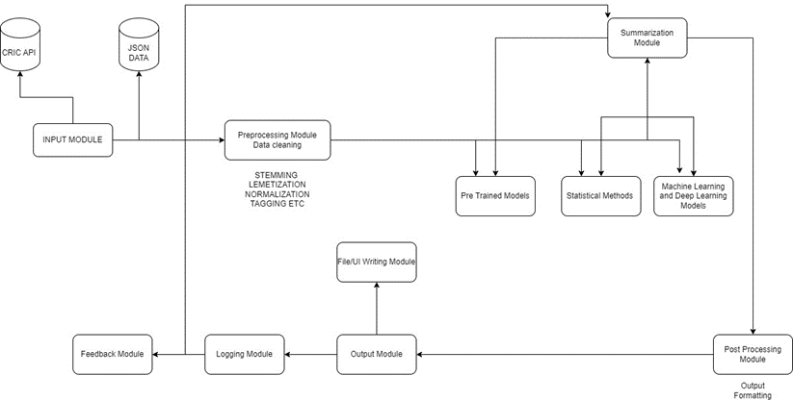

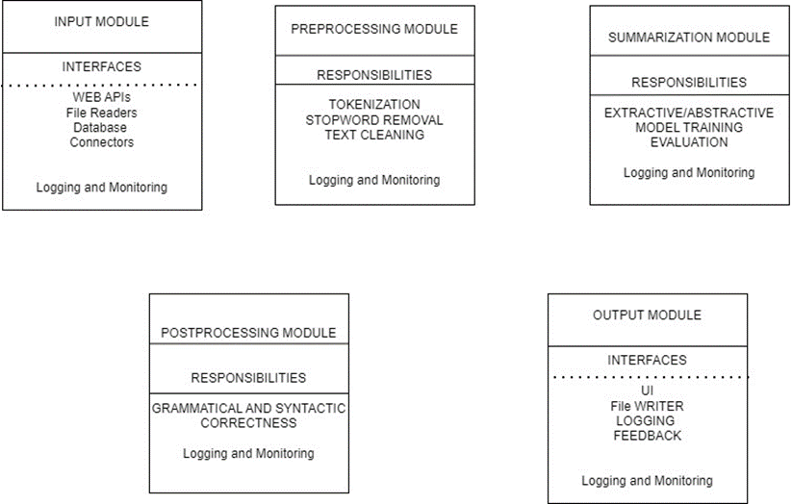

5.1 Input Module

The Input Module serves as a fundamental gateway within the system architecture, tasked with efficiently acquiring and preparing data for downstream processing. This module comprises several essential sub-components designed to handle diverse data sources and formats seamlessly.

One critical sub-component is the File Reader Interface, which plays a key role in reading and parsing data from specified files. This interface is adept at handling both structured (e.g., CSV) and unstructured (e.g., text, JSON) data formats. By extracting information from files, the File Reader Interface transforms raw data into a structured format suitable for subsequent analysis and manipulation within the system.

Another vital component is the API Connector, responsible for interfacing with external services via defined APIs to retrieve data in real-time or batches. This connector establishes communication protocols with external systems, facilitating the retrieval of dynamic or updated information required by the system for processing.

Additionally, the Database Interface enables seamless integration with databases, executing queries to fetch specific datasets efficiently. By leveraging database connections, this interface ensures optimized data retrieval and management, supporting the system's need for accessing structured datasets stored in relational or non-relational databases.

The Data Connectors within the Input Module serve as integrators, harmonizing data obtained from disparate sources such as files, APIs, and databases. These connectors unify data into a cohesive format suitable for downstream processing stages, ensuring consistency and compatibility across various data inputs.

Key tasks performed by the Input Module include Data Collection, which involves acquiring relevant information from specified sources, Data Parsing to structure raw data into a standardized format, and Error Handling to manage exceptions and ensure robust data retrieval and preprocessing.

In summary, the Input Module acts as a foundational component that orchestrates the intake of data from diverse origins, prepares it for subsequent processing, and maintains data integrity throughout the initial stages of the system workflow. Its robust functionality ensures the seamless transfer and transformation of raw data into actionable insights within the broader system architecture.

5.2 Preprocessing module

The Preprocessing Module is a pivotal component within the system's architecture, dedicated to refining and optimizing acquired data before it undergoes further processing. This module plays a crucial role in enhancing data quality and preparing it for subsequent stages of analysis and summarization.

One primary task of the Preprocessing Module is Data Cleaning, which involves identifying and rectifying outliers, errors, and irrelevant data points within the dataset. This process employs algorithms and techniques to handle noise and inconsistencies, such as removing duplicates, correcting typographical errors, and filtering out irrelevant sentences or words that could impede accurate analysis.

For handling Audio Data, the preprocessing phase ensures seamless integration by converting breaks or pauses in audio streams into text-equivalent whitespace. This transformation enables continuous data flow and compatibility with subsequent text-based preprocessing techniques.

Text preprocessing tasks within this module include Stemming, Lemmatization, Normalization, and Stop word Removal. Stemming reduces words to their base or root form (e.g., "running" to "run"), while lemmatization maps words to their dictionary form (e.g., "better" to "good"). Normalization standardizes text by converting to lowercase, removing punctuation, and handling special characters. Stop word removal filters out common words that do not contribute significant meaning to the text.

Another essential aspect of the Preprocessing Module is Feature Engineering, aimed at enhancing data representation for more effective analysis and summarization. This involves deriving new features or attributes from the raw data to capture relevant patterns and information, enabling the system to extract meaningful insights during the summarization process.

The overarching objectives of the Preprocessing Module include improving data quality, standardizing text data for consistent processing, and enhancing data representation through feature engineering. By executing robust preprocessing techniques, this module ensures that the data fed into subsequent stages of the system is refined, standardized, and optimized for generating accurate and actionable summaries from diverse and complex datasets. Its role is pivotal in setting the foundation for successful data analysis and summarization within the broader system architecture.

5.3 Summarization Techniques

5.3.1 Word Frequency Summary Generation

This technique is an extractive summarization technique which identifies words that play significant or important role in identifying the context of the sentence. It creates a word cloud internally that identifies the most important words in a corpus to generate summaries.

As data is already pre-processed it only contains the words that are important for generating summaries. For instance, consider below example for sample corpus and its summary using word frequency summary generation.

**Example:** Suppose we have a corpus of sports news articles. After pre-processing (removing stop words, stemming, etc.), we analyse the frequency of each word. In this corpus, words like "game," "team," "player," "score," "match," "win," etc., might have high frequencies.

For summarization:

* Sentences containing these important words (e.g., "The team won the match with a high score," "The player scored a hat-trick in the game") would be selected to form the summary.

Some of the key advantages for such an algorithm is that it is simple to implement and it requires less time to get response and thus is computationally inexpensive, it highlights important events occurring in a match, weights to words can also be controlled manually.

However, the technique is inefficient for large data as it becomes memory wise inefficient, context capturing in large data can be inefficient through this technique.

Post processing time for such a technique can be high as it only provides raw words that needs to be concatenated to form human readable summary.



5.3.2 TFIDF Sentence Scoring

This technique is a sentence scoring technique in which we calculate term frequency for every sentence in the corpus. For every word t in a sentence s we calculate it’s term frequency defined by number of times t appears in s divided by total number of words in s.

TF (t, s) = Number of times t appears in s

Total number of words in s

After computing term frequency, we determine inverse document frequency which quantifies how important a word is across a collection of documents.

IDF (t) = log(N/df(t))

where N represents total number of documents and df(t) is number of documents containing term t.

For each sentence s, calculate its TF-IDF score by summing up TF-IDF scores of all significant words (non-stop words) in the sentence.

TF_IDF SCORE(s) = ∑t€s TF (t,s) * IDF(t)

Then we sort the sentences based on their TF-IDF scores in descending order. Select the top-ranked sentences to form the summary. The number of sentences chosen can be a predefined ratio (e.g., 20% of the original text) or based on a threshold TF-IDF score.

Some of the advantages of this technique is it is straightforward to implement and is computationally inexpensive and provides quick responses. It is also effective in summarizing important events or details from the corpus.

Disadvantages:

Memory Inefficiency: Becomes inefficient with large datasets due to memory constraints.

Context Limitations: May struggle with capturing nuanced context in large or complex datasets.

Post-Processing Overhead: Requires additional processing to convert selected words into a coherent, human-readable summary.

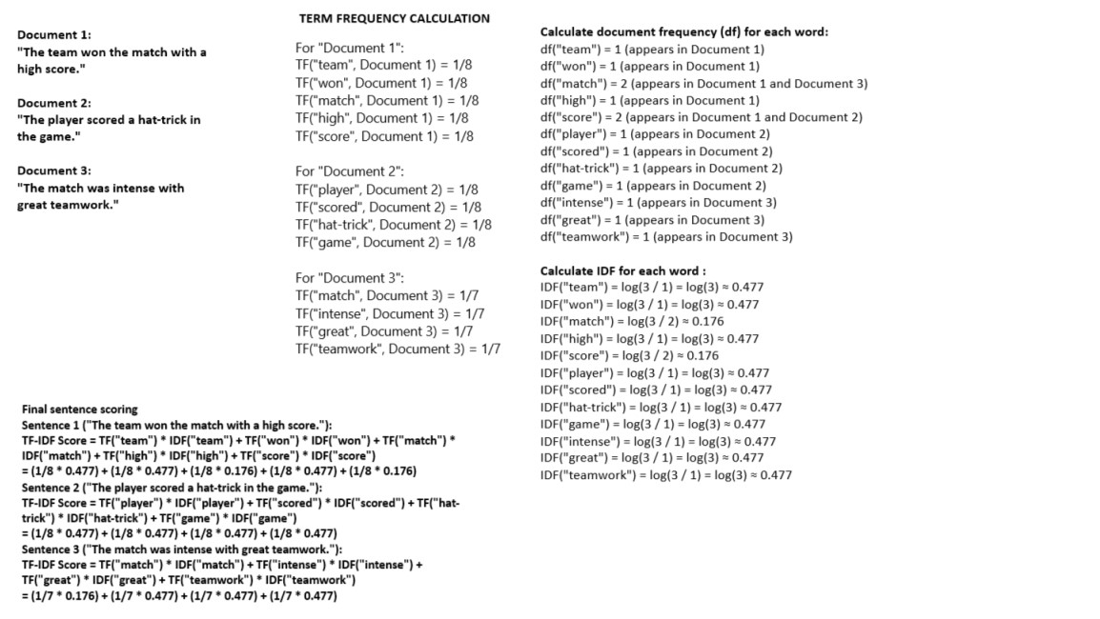

5.3.3 Weighted TFIDF Summary Generation

Weighted TF-IDF summary generation involves assigning higher importance or weight to sentences located at the beginning and end of a document. This approach aims to create more coherent and meaningful summaries by prioritizing the introduction and conclusion sections of the text.

Weights to initial sentences (Introduction) = w(i) = 1/i

Weights to final sentences (Conclusion) = w(i) = 1/N – i +1 where N represents total number of sentences.

The final summary will consist of sentences that are not only important based on their TF-IDF scores but also weighted to prioritize the introduction and conclusion sections, resulting in a more coherent and focused summary of the document.

Implementing weighted TF-IDF summary generation involves customizing the TF-IDF scoring process to incorporate positional weighting, which enhances the quality and relevance of the generated summary by emphasizing the beginning and end sections of the text.

5.3.4 Big Data integration in TFIDF Scoring

Big data integration in text summarization systems especially for streaming data provides many advantages over traditional TF-IDF summarization technique. It allows for horizontal scalability as far as computation power is needed.

It also provides features such as distributed computing, fault tolerance, fast processing etc. Apache spark leverages distributed computing and parallelism to apply big data technologies in traditional methods.

Apache Spark is designed to handle large-scale data processing across a cluster of machines. It distributes the data and computation across multiple nodes, enabling parallel processing. In the context of text summarization, this means that tasks like tokenization, counting word frequencies, and generating summaries can be executed in parallel across many machines, speeding up the overall process.

Spark provides fault tolerance through its resilient distributed datasets (RDDs) and the concept of lineage. RDDs keep track of the transformations applied to the data, enabling Spark to recompute lost data partitions automatically in case of node failures. This is crucial for continuous processing of streaming data in text summarization systems, where data reliability and uninterrupted operation are essential.

Spark leverages in-memory processing and optimized query execution plans to achieve high performance. By caching intermediate data in memory (or on disk when necessary), Spark reduces the need to read from disk repeatedly, which speeds up iterative algorithms like those used in summarization tasks. This speed is particularly advantageous for handling real-time or near-real-time data streams where low latency is critical.

Spark's architecture supports horizontal scalability, meaning you can easily add more nodes to the cluster as your data and computation needs grow. This scalability is vital for handling large volumes of streaming data efficiently. As the workload increases, more resources can be added to the Spark cluster to maintain performance without requiring significant changes to the underlying system.

Spark's core abstraction is the resilient distributed dataset (RDD), which allows data to be processed in parallel across a cluster. Spark automatically parallelizes the execution of tasks and optimizes data shuffling between nodes, making it efficient for distributed computing tasks like text summarization. Additionally, Spark provides higher-level APIs like Data Frames and Datasets, which further simplify parallel data processing and allow for complex operations on distributed data.

Apache Spark's architecture is designed to support large-scale distributed processing, making it an ideal platform for text summarization tasks. At the core of Spark's architecture is its compatibility with various cluster managers such as Apache YARN, Apache Mesos, or standalone mode, enabling resource allocation and management across cluster nodes. The cluster manager handles job scheduling and monitoring, ensuring efficient utilization of CPU and memory resources for Spark applications.

Within the Spark framework, the driver program plays a pivotal role as the main process responsible for coordinating the execution of Spark applications. It initializes the SparkContext (SC), which serves as the entry point for interacting with the Spark cluster. The SparkContext is responsible for coordinating the execution of operations across the cluster, communicating with the cluster manager to acquire necessary resources, and launching executors on worker nodes.

Executors are worker processes responsible for executing tasks on behalf of the driver program within each Spark application. Managed by the cluster manager, executors run computations and store intermediate data in memory or disk storage as required during task execution. This distributed execution model enables efficient parallel processing, crucial for handling large-scale text summarization tasks.

Central to Spark's data processing capabilities are Resilient Distributed Datasets (RDDs), which represent distributed collections of data that can be operated on in parallel. RDDs are fault-tolerant and immutable, allowing for iterative and distributed processing tasks essential for text summarization. They can be cached in memory across multiple operations, optimizing performance by minimizing data movements.

Spark's flexibility in data ingestion and output extends its utility for text summarization workflows. It can ingest data from various sources like HDFS, Amazon S3, or Kafka, enabling processing of streaming or static text data. Spark's preprocessing capabilities, including tasks like tokenization, cleaning, and feature extraction (e.g., TF-IDF, word embeddings), are distributed and scalable, efficiently preparing text data for summarization tasks.

In the text summarization workflow, Spark executes summarization algorithms (e.g., frequency-based, graph-based, or machine learning-based) on distributed data. This involves parallel execution of tasks such as word frequency counting, graph construction for sentence ranking, and model inference across the cluster, leveraging Spark's optimized execution engine.

The summarized results from distributed computations are aggregated back to the driver program, which manages data shuffling and aggregation efficiently. Spark's in-memory processing, data locality optimization, and task pipelining contribute to high-performance execution of text summarization tasks, reducing latency and improving overall throughput.

Ultimately, Spark's architecture provides significant benefits for text summarization, including scalability to handle large volumes of data, fault tolerance ensuring reliable processing in distributed environments, high performance through optimized data processing techniques, and flexibility in implementing and customizing summarization algorithms using a rich set of APIs and language support. This makes Apache Spark a powerful and versatile framework for building robust and efficient text summarization systems. Figure 5 represents a high-level overview of integration of Apache Spark in traditional text summarization algorithms.

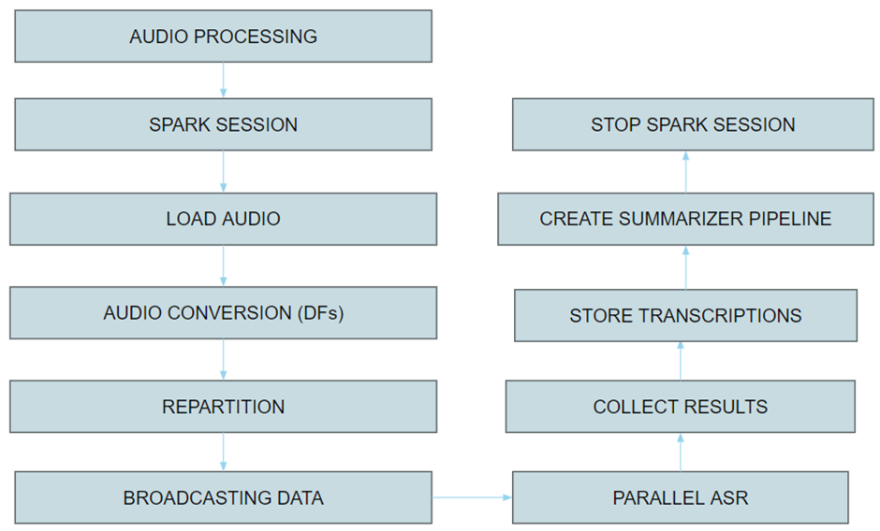

POST-PROCESSING AND OUTPUT

SUMMARIZATION MODULE

TRANSCRIPTS GENERATION

AUDIO PROCESSING

INPUT AGGREGATION

SPARK CONTAINER

5.3.5 Prompt Based Summarization

Prompt templates serve as a foundational tool in Langchain for automating text summarization tasks. By defining structured templates with placeholders, such as {speech} and {language}, users can input specific content (e.g., a speech) and desired parameters (e.g., target language) to generate customized summaries efficiently. This paper explores the technical workings and practical applications of prompt templates within Langchain's text summarization framework.

In recent years, automated text summarization has gained significant traction due to its ability to streamline information processing and enhance productivity. Prompt templates offer a structured approach to text summarization by facilitating the dynamic generation of summaries based on predefined input variables.

The motivation behind leveraging prompt templates in Langchain stems from the need to enable flexible and scalable text summarization solutions. Traditional summarization methods often require extensive manual effort and lack adaptability to diverse inputs. Prompt templates address these challenges by providing a framework for generating tailored summaries based on user-defined inputs.

The core of Langchain's text summarization framework lies in its prompt template engine. This engine interprets user-provided inputs, such as a speech ({speech}), and desired parameters ({language}), to construct personalized prompts for text generation models. The prompt is then processed to produce concise and informative summaries in the specified target language.

Behind the scenes, Langchain utilizes advanced natural language processing (NLP) techniques, powered by models like generative pre-trained transformers, to interpret and generate text based on prompt templates. This involves replacing placeholders within the template with actual content and executing the summarization process seamlessly.

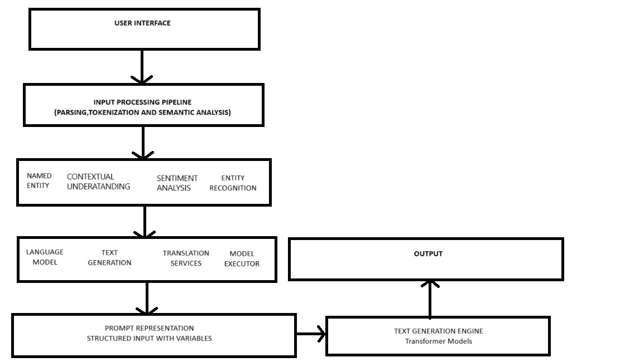

5.3.6 Summarization using Stuff Document Chain

Stuff document chain is a technique in which we leverage blockchain technology for text summarization. Smart contracts are basically used to summarize documents of data. Various stages and processes in stuff document chain are Data Ingestion and Storage, Semantic Analysis and Preprocessing, Summarization Engine, Decentralized Computation, Smart Contracts for Summarization, Output Generation and Delivery and Immutable Summaries and Auditability.

Before summarization can begin, textual documents undergo semantic analysis and preprocessing. This involves extracting essential information such as key entities, topics, and relationships from the documents. Tasks like tokenization, part-of-speech tagging, and named entity recognition (NER) are performed to structure and prepare the data for the summarization engine.

StuffDocumentChain integrates a powerful summarization engine that leverages advanced natural language processing (NLP) techniques. This engine can employ both extractive and abstractive summarization methods. In extractive summarization, important sentences or passages are selected from the original text. In abstractive summarization, the engine generates novel summaries based on the semantic understanding of the input.

One of the key advantages of using StuffDocumentChain for text summarization is its ability to harness distributed computing resources. Nodes within the blockchain network collaboratively process and analyze textual data, enabling scalable and efficient summarization tasks. This decentralized approach ensures that the summarization process is resilient and can handle large volumes of text data.

StuffDocumentChain utilizes smart contracts to automate and streamline summarization tasks. Users can interact with smart contracts deployed on the blockchain to request summaries of specific documents or collections of documents. This automation facilitates on-demand summarization and enhances the accessibility of the summarization services within the StuffDocumentChain ecosystem.

Summarized outputs generated within the StuffDocumentChain ecosystem are securely stored and can be accessed by authorized users. The summaries can be delivered in various formats (e.g., text, JSON) based on user preferences. This ensures that the summarization results are easily consumable and compatible with different applications and systems.

Summarized documents are stored as immutable records on the blockchain, providing transparency and auditability. Users can verify the integrity and authenticity of the summaries by referencing the blockchain ledger. This audit trail enhances trust and accountability in the summarization process, making it suitable for applications where data integrity is critical.

5.3.7 Map Reduce Architecture in Summarization Tasks

Map Reduce is another example of leveraging big data technologies in streaming data summarization tasks. The MapReduce summarization workflow enables efficient processing and summarization of large textual documents by leveraging distributed computing principles. This workflow begins with input splitting, where the document is segmented into manageable chunks. Each chunk represents a portion of the document that can be processed independently, akin to the mapping phase in MapReduce. This division allows for parallel processing, which is essential for handling large volumes of data effectively.

During the map phase of the workflow, each document chunk undergoes independent text processing using a map function. Text processing tasks such as tokenization, part-of-speech tagging, and named entity recognition (NER) are applied to extract meaningful information from the text. Tokenization breaks the text into words or tokens, while part-of-speech tagging assigns grammatical categories like nouns and verbs. NER identifies named entities such as persons or locations within the text.

The output of the map phase is a set of intermediate key-value pairs, where the key represents specific aspects of the text (e.g., entity type, topic) and the value contains relevant information (e.g., occurrence count, context). These intermediate results are temporarily stored and serve as input for the subsequent shuffle and sort phase.

In the shuffle and sort phase, the intermediate key-value pairs are shuffled and grouped together based on their keys. This data redistribution prepares the intermediate results for aggregation and reduction in the next phase. By grouping data with the same key across all chunks, this step facilitates efficient data processing and analysis.

The reduce phase involves aggregating and combining the intermediate results based on their keys. Summarization techniques are applied to distill the key information extracted from different chunks into a comprehensive summary of the entire document. Depending on the summarization approach (e.g., extractive or abstractive), the reduce function may prioritize key entities, important sentences, or generate novel text based on the aggregated information.

Finally, the output of the reduce phase is the final summary of the document, condensed from the processed chunks and intermediate results. This summary captures the essential information extracted from the large document, providing a concise representation suitable for further analysis or consumption.

In terms of implementation details, the MapReduce framework enables parallel processing of document chunks across distributed computing nodes, which significantly improves scalability and performance for large-scale summarization tasks. MapReduce frameworks like Apache Hadoop also provide built-in fault tolerance mechanisms to handle node failures and task retries automatically, ensuring robustness in distributed environments. Optimization techniques such as efficient data partitioning, combiner functions, and data locality optimizations further enhance the overall performance of MapReduce-based text summarization systems.

By applying the principles of MapReduce to text summarization, organizations can leverage distributed computing frameworks to process and summarize large volumes of textual data efficiently. This approach facilitates scalability, fault tolerance, and parallel processing capabilities essential for addressing big data challenges in natural language processing tasks.

INPUT DOCUMENT

INPUT SPLITTING  
(MAPPER INPUT)

MAP PHASE (TEXT PROCESSING)

TOKENIZATION,POS TAGGING,NER

GENERATE INTERMEDIATE KEY VALUE PAIRS

SHUFFLE AND SORT  
(GROUP INTERMEDIATE PAIRS BY KEYS)

REDUCE PHASE (SUMMARIZATION)

AGGREAGATE AND GENERATE FINAL SUMMARY

MAP REDUCE ENVIRONMENT - LANGCHAIN

5.3.8 Refined Text Summarization

The inner workings of a refined text summarization chain involve a sophisticated process leveraging advanced natural language processing (NLP) techniques to generate high-quality and detailed summaries from input text. This refined chain begins with the initialization and setup, where a specific language model (llm) is selected to power the summarization process, focusing on refinement-oriented approaches indicated by parameters like chain_type='refine'. The use of verbose mode (verbose=True) allows for detailed logging and output during each step of the summarization, aiding in transparency and troubleshooting.

Once initialized, the summarization chain handles input text (chunks) by first preprocessing it to prepare for refinement. This preprocessing involves tasks like tokenization and sentence segmentation to break down the text into manageable units for analysis. The chain then conducts in-depth text analysis using the chosen language model (llm), applying advanced NLP techniques such as named entity recognition (NER), part-of-speech tagging, and dependency parsing to extract key features and entities from the input.

The core of the refinement chain lies in its iterative summarization process. Initial summarization generates a draft summary based on the extracted features and entities from the input text. This draft undergoes iterative refinement where various techniques are employed to enhance the quality and detail of the summary. These refinement strategies may include emphasizing important named entities, capturing nuanced meanings through contextual understanding, and integrating sentiment analysis to convey emotional tone and context.

Throughout the refinement process, the chain incorporates feedback loops to continually improve the summary based on intermediate results and analysis. Feedback may be obtained from model evaluations, human annotators, or heuristic rules, guiding the refinement process to optimize the final summary output. The output of the refinement chain is a finalized, refined summary that encapsulates essential information and insights from the input text in a structured and coherent manner.

Detailed logging and output (verbose=True) provide transparency into the summarization process, including intermediate results, key insights, and refinement steps. This aids in understanding the summarization workflow and allows for effective troubleshooting and optimization. By leveraging a refined text summarization chain with advanced NLP capabilities and iterative refinement strategies, organizations can achieve superior summarization quality tailored to diverse use cases and domains, effectively extracting key insights from large volumes of textual data.

1. **Performance Measures of the model**

Below are the highlights of each model based on scalability, efficiency and 3

SCALABILITY EFFICIENCY QUALITY (ROUGE SCORE)

|  |  |  |  |
| --- | --- | --- | --- |
| Word Frequency | LOW | HIGH | 0.2 (LOW) |
| TFIDF Score | LOW | HIGH | 0.52 (MED - HIGH) |
| Weighted TFIDF | LOW | HIGH | 0.57 (MED - HIGH) |
| Spark with TFIDF | HIGH | MEDIUM | 0.54 (MED - HIGH) |
| Prompt Based Summarization | MEDIUM | MEDIUM | 0.62 (HIGH) |
| Stuff Document Chain | REL HIGH | MEDIUM | 0.72 (HIGH) |
| Map Reduce Based Summarization | HIGH | MEDIUM | 0.87(HIGH) |
| Refined Text based Summarization | REL HIGH | MEDIUM - HIGH | 0.79 (HIGH) |

In evaluating various text summarization methods based on their scalability, efficiency, and quality as measured by ROUGE scores, several insights can be gleaned. Simple approaches like Word Frequency-based summarization exhibit high efficiency but limited quality, evidenced by a low ROUGE score of 0.2, indicating a struggle to capture essential content from source documents. TFIDF-based summarization, which considers term importance, shows improved quality with a ROUGE score of 0.52, suggesting a better ability to extract relevant information. Weighted TFIDF further enhances summarization quality (0.57 ROUGE score) by emphasizing key terms. Spark with TFIDF demonstrates higher scalability with a slightly lower ROUGE score (0.54), suggesting a trade-off between efficiency and quality due to distributed processing. Prompt-based summarization achieves a commendable ROUGE score of 0.62 by leveraging sophisticated language models and tailored prompts. The Stuff Document Chain method, known for its scalability, achieves a high-quality summary (0.72 ROUGE score) through iterative processing. MapReduce-based summarization stands out with a high scalability and efficiency, resulting in a high-quality summary (0.87 ROUGE score) through distributed processing. Refined Text-based summarization also scores well (0.79 ROUGE score) by leveraging iterative refinement processes and advanced text processing techniques to produce high-quality summaries. These analyses highlight the trade-offs and strengths of different summarization methods, illustrating how scalability, efficiency, and quality interact within the context of text summarization tasks.

1. CONCLUSION

Thus, we conclude that there are various modules involved in summarization module. We see various factors that are involved, various processes involved in creating extractive and abstractive summaries of audio data especially streaming data like sports. We saw how different techniques provides a trade-off between efficiency, scalability and summary quality.

In conclusion, the evaluation and comparison of various text summarization methods based on scalability, efficiency, and quality (as measured by ROUGE scores) reveal important insights into the strengths and trade-offs of each approach.

Word Frequency-based summarization, although highly efficient, demonstrates limited quality with a low ROUGE score of 0.2, indicating challenges in capturing essential content from source documents. TFIDF-based summarization improves upon this with a ROUGE score of 0.52, suggesting better extraction of relevant information by considering term importance. Weighted TFIDF further enhances summarization quality (0.57 ROUGE score) by emphasizing key terms.

Spark with TFIDF achieves higher scalability but slightly compromises efficiency and quality (ROUGE score of 0.54) due to distributed processing. Prompt-based summarization leverages sophisticated language models to achieve a commendable ROUGE score of 0.62, demonstrating effectiveness in generating high-quality summaries. The Stuff Document Chain method, known for scalability, achieves a high-quality summary (0.72 ROUGE score) through iterative processing.

MapReduce-based summarization stands out with high scalability and efficiency, producing a high-quality summary (0.87 ROUGE score) through distributed processing. Refined Text-based summarization also scores well (0.79 ROUGE score) by leveraging iterative refinement processes and advanced text processing techniques.

These analyses underscore the importance of balancing scalability, efficiency, and summary quality in text summarization tasks. Each method offers unique advantages and challenges, emphasizing the need to choose an approach that aligns with specific requirements and objectives. By understanding these trade-offs, practitioners can make informed decisions when selecting text summarization techniques tailored to their application scenarios and data characteristics.

1. **Future Aspects**

A user interface can be designed so user can interact with different models and can compare all the model’s summaries as well as transcripts and provide feedbacks for improvement. Another key aspect while deploying is to ensure proper load balancing when using blockchain based or map reduce based models.

New large language models and transformer architectures can be used to enhance quality of content semantically and syntactically continuously. So here we can integrate continuous improvement pipeline.

1. **REFERENCES**

[1] https://www.devlinpeck.com/content/online-learning-statistics#:~:text=77%25%20of%20public%20college%20students%20take%20at%20least%20one%20online%20course&text=More%20than%203%20in%204%20public%20college%20students%20take%20at,just%2068%25%20of%20whom%20will.

[2]<https://www.who.int/news-room/fact-sheets/detail/deafness-and-hearing-loss#:~:text=Overview,will%20have%20disabling%20hearing%20loss>.

[3] Z. Chen, J. Droppo, J. Li, and W. Xiong, "Progressive Joint Modeling in Unsupervised Single-Channel Overlapped Speech Recognition," IEEE/ACM Transactions on Audio, Speech, and Language Processing, vol. 26, no. 1, pp. 184-196, Jan. 2018, doi: 10.1109/TASLP.2017.2765834.

[4] N. Hirayama, K. Yoshino, K. Itoyama, S. Mori, and H. G. Okuno, "Automatic Speech Recognition for Mixed Dialect Utterances by Mixing Dialect Language Models," IEEE/ACM Transactions on Audio, Speech, and Language Processing, vol. 23, no. 2, pp. 373-382, Feb. 2015, doi: 10.1109/TASLP.2014.2387414.

[5]Chenghao Cai, Yanyan Xu, Dengfeng Ke, Kaile Su, "A Fast Learning Method for Multilayer Perceptrons in Automatic Speech Recognition Systems", Journal of Robotics, vol. 2015, Article ID 797083, 7 pages, 2015. https://doi.org/10.1155/2015/797083

[6]Z. Chen, J. Droppo, J. Li, and W. Xiong, "Progressive Joint Modeling in Unsupervised Single-Channel Overlapped Speech Recognition," IEEE/ACM Transactions on Audio, Speech, and Language Processing, vol. 26, no. 1, pp. 184-196, Jan. 2018, doi: 10.1109/TASLP.2017.2765834.

[7] J. Verbraeken, M. Wolting, J. Katzy, J. Kloppenburg, T. Verbelen, and J. S. Rellermeyer, "A Survey on Distributed Machine Learning," ACM Comput. Surv., vol. 53, no. 2, Article 30, Mar. 2021, 33 pages, https://doi.org/10.1145/3377454.

[8] L. Lamport and N. Lynch, "CHAPTER 18 - Distributed Computing: Models and Methods," in Handbook of Theoretical Computer Science: Formal Models and Semantics, J. van Leeuwen, Ed., Elsevier, 1990, pp. 1157-1199, ISBN: 9780444880741, https://doi.org/10.1016/B978-0-444-88074-1.50023-8.

[9]P. K. Sharma, J. H. Park, and K. Cho, "Blockchain and federated learning-based distributed computing defence framework for sustainable society," Sustainable Cities and Society, vol. 59, p. 102220, 2020, ISSN 2210-6707, <https://doi.org/10.1016/j.scs.2020.102220>.

[10] T. Alam, "Cloud Computing and Its Role in the Information Technology," SSRN Electronic Journal, 2020. [Online]. Available: 10.2139/ssrn.3639063.

[11]Jn Ahnn.(2014).Scalable big data computing for the personalization of machine learned models and its application to automatic speech recognition service.2014 IEEE International Conference on Big Data (Big Data), 2014

[12]O Kapralova, J Alex, E Weinstein, P Moreno, O Siohan.(2014).A big data approach to acoustic model training corpus selection.

[13]https://www.mdpi.com/2076-3417/12/9/4419

[14]J Li.(2022).Recent advances in end-to-end automatic speech recognition.APSIPA Transactions on Signal and Information Processing, 2022